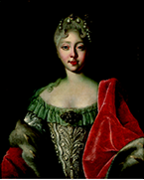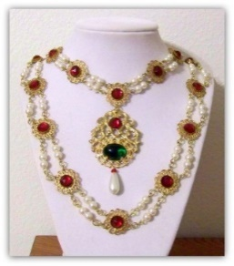--

|  |  |  |  |  |
| --- | --- | --- | --- | --- |
| **Agenda 24 February - 06 march** | |  |  |  |
| Monday 24 Feb. | **Back to school**  **This week report meetings by appointment. (and sign ups for FIEP). Ajax Clinics groups 6 to 8. ( you received a letter about this ). All-in-1 Theme Middle Ages week 5: States.  VLL kern 8 “what can you do?”.**  **Theme lower grades ‘’ Sil and the animals‘’.** |  |  |  |
| Tuesday 25 Feb. | **Report meetings by appointment. (and sign ups for FIEP). Hermitage group 4a and 4-5b, students have to be at school at 8.15. Start DKJL for groups 6-7b and 7a, see explanation for further information.** |  |  |  |
| Wednesday 26 Feb. | **Report meetings by appointment. (and sign ups for FIEP). Hermitage group 5a, students have to be at school at 8.15. Ms Merle teaching group 7a** |  |  |  |
| Thursday 27 Feb. | **Report meetings by appointment. (and sign ups for FIEP). Hermitage group 6a and 6b, students have to be at school at 8.15. Introduction moment new lower grade students** |  |  |  |
| Friday 28 Feb. | **Report meetings by appointment. (and sign ups for FIEP). Ending Theme Middle Ages.** |  |  |  |
| Monday 02 March. | **All-apart week 7 : The Diary Lesson 9 Kanjer training group 1 to 8.  D66 MPS at de Blauwe Lijn** |  |  |  |
| Tuesday 03 March. | **Parent afternoon Media Knowledge from 17.00 to 18.00 h. Ms Els not present** |  |  |  |
| Thursday 05 March. | **DeLaMar theatre ‘’ Family First’’ group 8a+b and 4-5b. Group 1 to 3 go to Artis. ( you have received a letter ).** |  |  |  |
| Friday 06 March. | **DKJL lesson 2 for group 6-7b and 7a. Technic lessons group 7 by FAWAKA worker school.  Child disco from group 6 and up from 18.00 to 20.00 h.** |  |  |  |

Hermitage group 4 to 6b

**On Tuesdays, Wednesdays and Thursdays, students from groups 4, 5 and 6** attend the Hermitage Amsterdam exhibition "Jewels."

They will be introduced to empresses Anna, Elisabeth and Catherine the Great, but also the great princes, tsarina's and noble fashionistas from the nineteenth and early twentieth centuries. They wore the most beautiful costumes at balls and parties. They chose jewelery that showed their identity, taste, origin and wealth.

The students are expected at 9 in the hermitage near Waterlooplein, so it is very important that we leave on time.

**Make sure your child is at school at 8:15**, the groups will then leave immediately!

They are back at school around 13:00.

**13-01-2020**

**Newsline nr.11**

De Blauwe Lijn

xAfbeelding met koptekst voor nieuwsbrief

Afbeelding van bloem



learn to discuss

Newsline nr.11 page 2

Groups 6 / 7b and 7a have started the project "Learn to discuss". This project focuses on strengthening the oral language, discussing difficult topics and offers children and young people (6 to 26) a platform to let their voices be heard.

Discussions between and with children and young people are often surprising and spontaneous. But can also be difficult. Because the subject is sensitive, because children have difficulty with the Dutch language, because children like to talk but forget to listen or because a discussion can lead to a fight.

DKJL helps teachers, students and parents to master the skills of discussion. Based on current themes, students are taught discussion skills in a playful and constructive manner.

In the coming weeks the groups will receive a guest lesson every Tuesday to develop these competencies.

From both classes, the student who can discuss best can participate in the debate battle.

## Theme middle ages week 5 : states

**ABC:**

The Netherlands is a kingdom headed by a king or queen.

Together with the government, he / she rules our country.

The government consists of ministers and the prime minister is in charge of this.

In the Middle Ages, the Netherlands consisted of many small countries.

Most of the lands were from the German king.

Every country had its own boss: a count, a duke or a bishop.

Only the Frisians arranged their affairs themselves.

The counts, bishops and dukes argued a lot.

They all wanted a larger area.

Between 1400 and 1500 many lands came into the possession of dukes.

They wanted to make all the countries into one.

Only after 1500 the seventeen lands became one.

They became seventeen regions of the Netherlands.

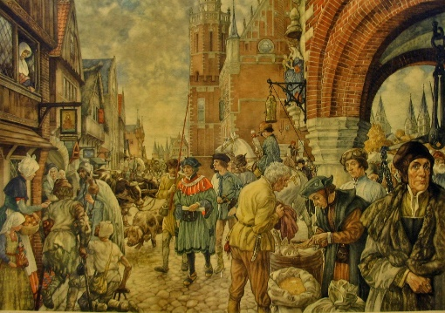

We will close the Middle Ages theme on **Friday 28 February.**

We will be holding a medieval market in circuit form.

The students go along different classes where fun medieval activities will take place according to schedule. For example, they will make a witch potion, participate in a knight's tournament, play a quiz game to test their medieval knowledge and make a medieval slingshot.

## ending Theme middle ages

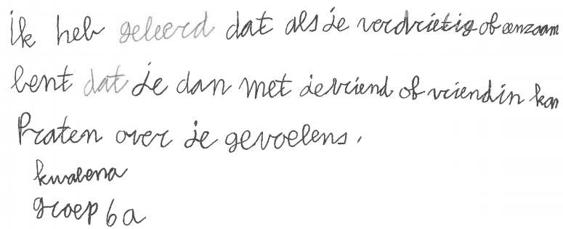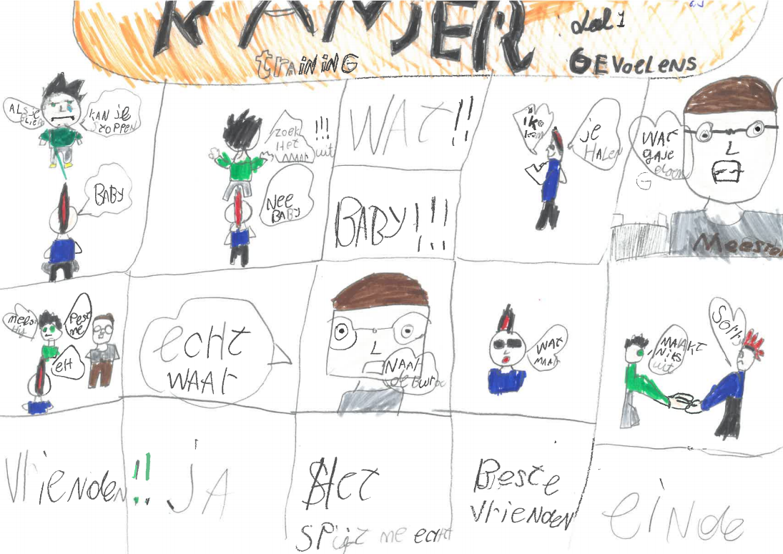

We believe it is important that the children of Amsterdam Zuidoost become acquainted with role models in art and experience a special day in one of the most beautiful theaters in Amsterdam, Delamar.

**On Thursday 5 March**, those pupils from groups 4-5b and 8a + b leave school at half past eight and are back at school around 13:00.

Also presented this year by Howard Komproe, we watch the show "Family First" together, made and performed by a group of enthusiastic young actors from Zuidoost. We will watch a short movie and there will of course be dancing. In short, all the ingredients to make it a party!

Would you like to join us as a guide? Report it to your child's teacher.

Do not give your child food or drinks, it is not allowed to eat or drink in the room.

This lesson kern is about being able to see feelings. Can you always see how others feel about others? And what if you walk around with something that makes you feel uncomfortable? Group 6a has thought about it well and can increasingly assess and apply situations. Below several assignments that they have carried out.

Kanjer training Lesson 7 : Guess feelings

DeLAmar theatre

newsline nr.11 page 3

the blauwe bijtjes

The toddler groups are busy with the theme hugs for the next 4 weeks. You can do fun home activities that have to do with going to sleep with your child. Reading a book, mood lamp, pajamas, brushing teeth. You can also think about what you put in your child’s suitcase when they go out to stay with a friend for the night. Toothbrush, a teddy bear, pajamas and a reading book.

Kind regards,

The teachers

newsline nr.11 page 4

Afbeelding van hek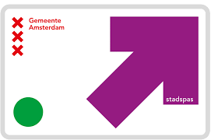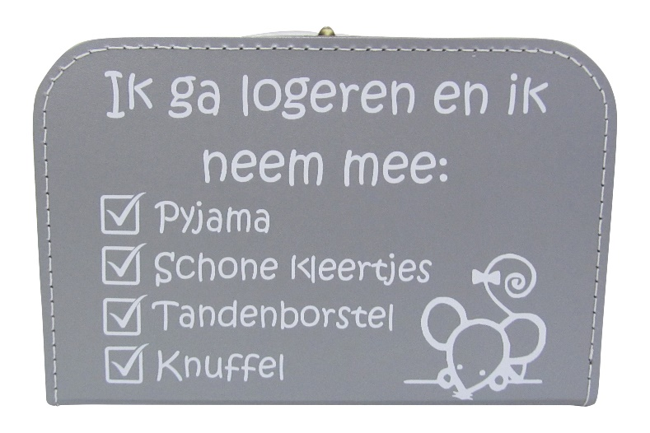

De Blauwe Lijn

Kortvoort 61A, 1104NA Amsterdam

Phone: (020) 690 73 60

E-Mail address: directie@deblauwelijn.nl

Personal letters will soon be sent out again. Have you not yet paid a parental contribution? Then you can expect a letter.

The parent' council must get the money from the budget. Our goal is to receive all payments by the beginning of April. In this way we can pay the school trip and camp on time.

The parent contribution is 50 euros and can be transferred to:  
**NL47 INGB 0009 2164 05 Beheer ouderraadsgelden de Blauwe Lijn.**

Please mention your child’s name and group

parent contribution